Practical no 6

**Persistent Cross-Site Scripting Attack**

Cross-Site Scripting Attack using testphp.vulnweb.com

Open website go to the inspect copy the input filed end tag paste into in name section and add our script

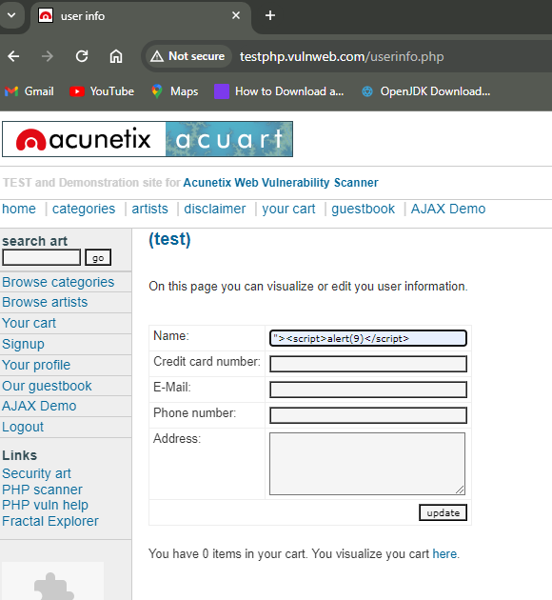

Whenever we click on update it will give us alert message

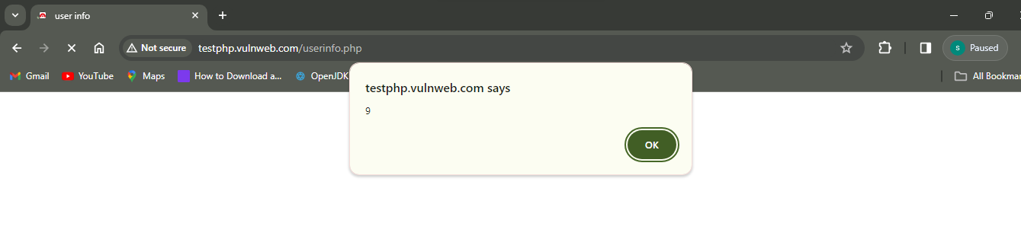

We can add html tag also here I can use the h1 tag and give name

In this case when we click on the update button it will give me the test HARSH

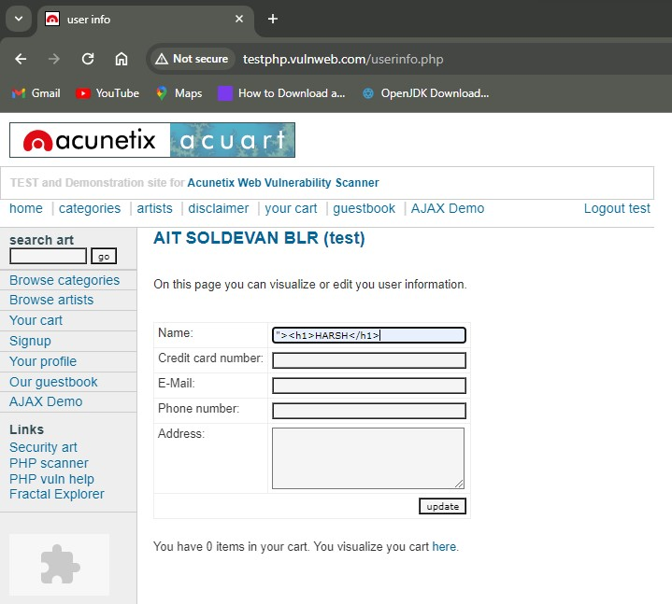

After click on update button

Output

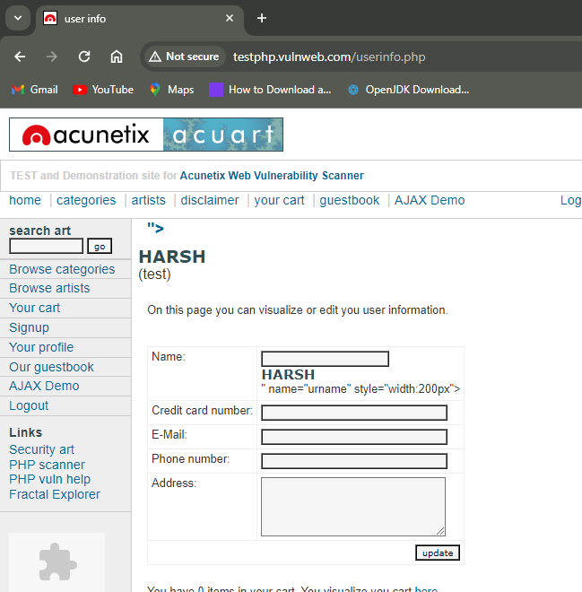

**We can open another window in another website using iframe**   
  
so here we can open our college website in testphp.vulnweb.com

Within the iframe tag we are give to the path of our college website using src attributes

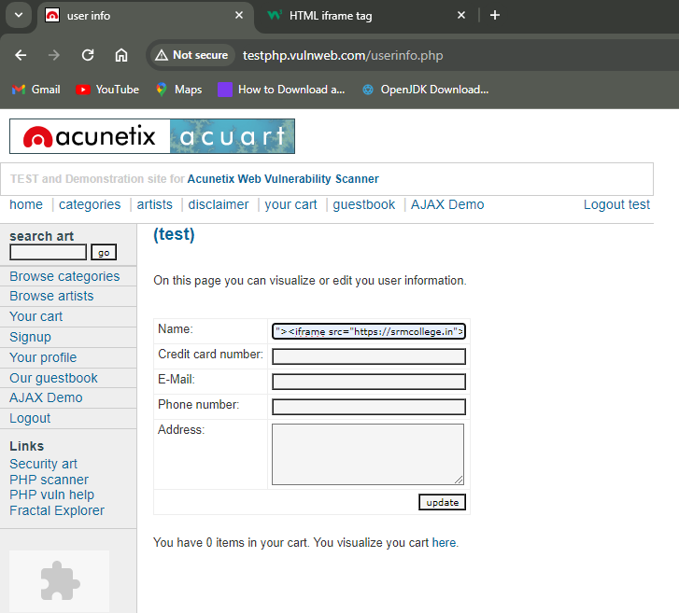

Now we can see in url open testphp.vulnweb.com website but with in that website we can seen our college website

